SELETOR:
'tag' {} é tag
ponto {} é classe
hashtag é id
'tag' com [atributo] é a classe com o atributo
* é geral */ B

CASCATE:
1-Specificity:
1-id
2-atribute
3-class
4-element (tag)

2-Type:
1-inline ---- e.g. <h1 style=" ">Hello</h1>
2-internal ---- <style> </style>
3-external ---- use css

3-Importance:
keyword: important
e.g.já color: green !important;

MULTIPLES SELECTORS:
Grupe: e.g.
selector, selector {color: blue}

Child: e.g.
selector > selector {color: red}

Descendant e.g.
selector selector selector {color: green}

Chaining e.g.
selectorselectorselector {color: gray}

Combiners e.g.
selector selectorselector {font-size 0.5rem}

POSITION

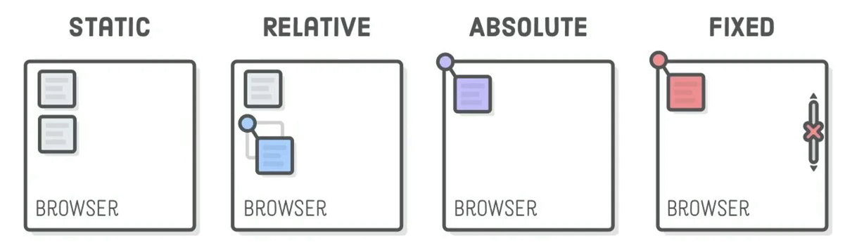

Static (default)
Relative: Relativo a posição original
Absolute: Relativo ao canto superior esquerdo da webpage
Fixed: Relativo ao canto superior esquerdo do navegador (mesmo com o scroll)
*z-Index: Define o que fica na frente do que (default z-Index = 0)

+=+ FLEX:
display: flex

flex-direction: row-reverse -- column-reverse;

order: refer to only one item, set the position related to a number

justify-content: define position in the width

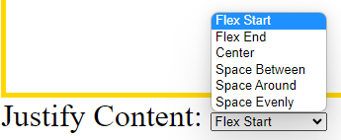

Flex-wrap: no-wrap (standard), wrap, wrap-reverse

align-items (no-wrap) or align-content (wrap): define position in the height

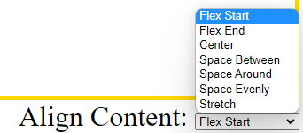

----------------------

+=+ GRID:

display: grid

grid e.g.: grid-template-columns: 1fr 1fr 2fr;
grid-template-rows: 1fr 1fr;

grid-row: span 2
grid-column: span 2

grid-area: firstline / firstcolunm / lastline / lastcolunm

----------------------

+=+ BOOTSTRAP:

